AI RESUME ANALYZER

Project Report
Submitted By : Preeti
Roll No : 301311323089
Department : Computer Science and Engineering (Artificial Intelligence)
College : Rungta College of Engineering & Technology, Bhilai
Academic Session : 2025–2026
Guide : Mr. Kailash Kumar Patel

CERTIFICATE

This is to certify that the project entitled "AI Resume Analyzer" submitted by Preeti (Roll No. 301311323089) in partial fulfilment of the requirements for the award of Bachelor of Technology in Computer Science and Engineering (Artificial Intelligence) has been carried out under our guidance during the academic session 2025-2026.

The work presented in this report is original and has not been submitted to any other university or institution for the award of any degree or diploma.

ACKNOWLEDGEMENT

I would like to express my sincere gratitude to my respected guide for providing valuable guidance, encouragement, and continuous support throughout the development of this project.

I am thankful to the faculty members of the Department of Computer Science and Engineering (Artificial Intelligence), Rungta College of Engineering & Technology, for their suggestions and motivation.

I would also like to thank my friends and family members for their constant encouragement and support during the completion of this project. Their guidance and motivation helped me successfully complete this work.

ABSTRACT

Artificial Intelligence is transforming the recruitment process by automating repetitive tasks and improving the efficiency of candidate selection. The AI Resume Analyzer is a web-based application developed using Python and Flask that analyses resume automatically and compares them with a given job description.

The system extracts text from uploaded PDF resumes using the PyPDF2 library. After extracting the text, the application identifies important technical skills such as Python, HTML, CSS, JavaScript, SQL, Machine Learning, Artificial Intelligence, and other programming technologies. These extracted skills are then compared with the skills mentioned in the job description.

The application calculates a resume matching score based on the similarity between the resume content and the job requirements. It also displays the matched skills and missing skills so that candidates can improve their resumes according to industry requirements.

The project reduces manual effort, saves recruitment time, improves hiring efficiency, and provides quick feedback to job seekers regarding their resume quality.

INTRODUCTION

Recruitment is one of the most important processes in every organization. Companies receive hundreds or even thousands of resumes for a single job opening. Manually reading and analysing every resume requires significant time and effort. Human errors, inconsistency, and bias can also affect the selection process.

-2-

The AI resume Analyzer is designed to automate resume screening by using Artificial Intelligence concepts and text processing techniques. Instead of manually checking resumes, the application extracts important information from the uploaded resume and compares it with the job description provided by the recruiter.

The application identifies technical skills present in the resume and calculates a matching score based on the similarity between the resume and job requirements. It also highlights missing skills that are required for the job but are absent in the candidate's resume. This project provides a faster, more accurate, and user-friendly solution for resume analysis. It benefits both recruiters and job seekers by simplifying the recruitment process and improving resume quality.

PROBLEM STATEMENT

Many organizations receive a large number of resumes for every recruitment process. Manual resume screening consumes a significant amount of time and often results in inconsistent evaluation. Recruiters may overlook suitable candidates due to human error, while candidates may not know which important skills are missing from their resumes.

The main objective of this project is to automate the resume screening process by extracting resume content, identifying technical skills, comparing them with job requirements, and generating an accurate matching score. This system helps recruiters shortlist candidates efficiently while providing useful feedback to applicants.

OBJECTIVES

- The major objectives of the AI Resume Analyzer project are:
- To automate the resume screening process.
- To upload and analyse PDF resumes.
- To extract textual information from resumes.
- To identify technical skills automatically.
- To compare resume skills with job descriptions.
- To calculate a resume matching score.
- To display matched skills and missing skills.
- To reduce recruitment time.
- To improve hiring accuracy.
- To provide useful feedback to job seekers.

SCOPE OF THE PROJECT

The AI Resume Analyzer can be used by companies, HR departments, recruitment agencies, educational institutions, and job seekers. It provides an intelligent solution for evaluating resumes quickly and efficiently.

The application helps recruiters identify suitable candidates without manually reading every resume. Job seekers can also use the system to improve their resumes by understanding which important skills are missing according to specific job requirements.

Future versions of the system can include Natural Language Processing (NLP), Machine Learning models, ATS score prediction, cloud deployment, database integration, multiple resume comparison, and recommendation systems.

-3-
EXISTING SYSTEM

In the traditional recruitment process, recruiters manually read resumes and compare them with job requirements. This process requires considerable time and effort, especially when a large number of applications are received.

Disadvantages of Existing System

- Manual resume screening
- Time-consuming process
- High probability of human error
- Difficult to analyse multiple resumes
- No automatic skill extraction
- No resume scoring system
- Recruitment becomes slow

PROPOSED SYSTEM

The proposed AI Resume Analyzer automates resume analysis using Artificial Intelligence concepts. The application extracts text from uploaded resumes, identifies technical skills, compares them with the job description, and calculates a matching score.

The system also displays matched skills and missing skills, allowing recruiters to shortlist candidates efficiently and helping candidates improve their resumes.

Advantages of Proposed System

- Automatic resume analysis
- Fast skill extraction
- Resume matching score
- Missing skills identification
- User-friendly interface
- Reduced manual effort
- Faster recruitment process

TECHNOLOGY STACK

The AI Resume Analyzer project has been developed using modern web technologies and Python libraries. Each technology plays an important role in the successful implementation of the application.

Python

Python is the primary programming language used for developing this project. It provides a simple syntax, powerful libraries, and excellent support for Artificial Intelligence and Machine Learning applications. Python is responsible for processing the uploaded resume, extracting text, comparing skills, and generating the final output.

Flask

Flask is a lightweight Python web framework used for developing the web application. It manages communication between the front-end and the back-end. Flask receives the uploaded resume from the user, processes the data, and displays the final result on the web page.

-4-
HTML

HTML (Hyper Text Markup Language) is used for creating the structure of the application's user interface. It provides the webpage where users upload resumes and enter job descriptions.

CSS

CSS (Cascading Style Sheets) is used to improve the appearance of the web application. It provides styling, colours, spacing, fonts, buttons, and overall layout to make the interface user-friendly.

PyPDF2

PyPDF2 is a Python library used to extract text from PDF files. It reads the uploaded resume and converts its contents into text that can be analysed by the application.

VS Code

Visual Studio Code is the development environment used for writing, editing, debugging, and executing the project.

GitHub

GitHub is used to maintain the project repository. It stores the source code, documentation, screenshots, presentation, and project report.

SOFTWARE REQUIREMENTS

The following software components are required for the successful execution of this project.

- Operating System: Windows 10/11
- Programming Language: Python 3.10
- IDE: Visual Studio Code
- Web Framework: Flask
- Browser: Google Chrome / Microsoft Edge
- Version Control: Git & GitHub

HARDWARE REQUIREMENTS

The project can run on any standard computer system.

Minimum Requirements:

- Intel Core i3 Processor or higher
- 4 GB RAM
- 20 GB Free Storage
- Internet Connection
- Keyboard and Mouse

Recommended Requirements:

- Intel Core i5/i7 Processor
- 8 GB RAM
- SSD Storage
- Windows 11

-5-

SYSTEM ARCHITECTURE

The AI Resume Analyzer follows a simple client-server architecture.

User

↓

Upload Resume (PDF)

↓

Flask Web Application

↓

Text Extraction using PyPDF2

↓

Skill Detection

↓

Job Description Matching

↓

Match Score Calculation

↓

Display

The user uploads a PDF resume using the web interface. Flask receives the uploaded file and sends it to the PyPDF2 library for text extraction. The extracted text is analysed to identify technical skills. These skills are then compared with the skills mentioned in the job description. Finally, the system calculates a matching score and displays the matched skills, missing skills, and overall analysis.

WORKFLOW OF THE PROJECT

The complete working process of the AI Resume Analyzer consists of the following steps.

Step 1: Resume Upload

The user uploads a PDF resume through the web interface.

Step 2: Text Extraction

The PyPDF2 library extracts all textual information from the uploaded resume.

Step 3: Skill Identification

The application scans the extracted text and identifies technical skills such as Python, HTML, CSS, JavaScript, SQL, Machine Learning, and Artificial Intelligence.

-6-

Step 4: Job Description Input

The recruiter or user enters the job description containing required skills.

Step 5: Skill Comparison

The extracted resume skills are compared with the required job skills.

Step 6: Match Score Generation

The application calculates the percentage of matching skills.

Step 7: Display Result

The system displays the Match Score, Matched Skills, and Missing Skills on the screen.

PROJECT MODULES

The AI Resume Analyzer consists of the following modules.

1. Resume Upload Module

This module allows users to upload resumes in PDF format.

2. Resume Processing Module

This module extracts text from the uploaded resume using the PyPDF2 library.

3. Skill Detection Module

The extracted text is analysed to detect technical skills.

4. Job Description Module

The recruiter enters the required job description.

5. Resume Matching Module

The application compares the detected skills with the required skills.

6. Result Module

The final result displays the Match Score, Matched Skills, and Missing Skills.

ALGORITHM

The AI Resume Analyzer follows the following algorithm:

Step 1

Start the application.

Step 2

Upload the resume in PDF format.
-7-
Step 3

Extract text using PyPDF2.

Step 4

Identify technical skills.

Step 5

Accept Job Description.

Step 6

Compare resume skills with job description.

Step 7

Calculate Match Score.

Step 8

Display Match Score, Matched Skills, and Missing Skills.

Step 9

Stop the application.

IMPLEMENTATION

The implementation of AI Resume Analyzer begins with the development of a Flask web application. The front-end is created using HTML and CSS, while the back-end is developed using Python.

The application first receives the uploaded PDF resume from the user. The PyPDF2 library extracts all textual information from the document. After extracting the text, the system identifies technical skills based on predefined keywords.

The extracted skills are then compared with the skills present in the job description. The application calculates the matching percentage and displays the final analysis to the user.

The project was successfully executed in Visual Studio Code using Python and Flask. The results confirmed that the application correctly identifies technical skills and generates meaningful resume analysis.

RESULTS AND DISCUSSION

The AI Resume Analyzer was successfully implemented and tested using multiple sample resumes and different job descriptions. The application correctly extracted text from uploaded PDF files and identified the technical skills mentioned in the resumes.

The system compared the extracted skills with the job description entered by the user. Based on the comparison, it generated an overall Match Score along with a list of matched skills and missing skills. The generated results were displayed on the web interface in an easy-to-understand format.
-8-

The application successfully analysed resumes containing skills such as Python, HTML, CSS, JavaScript, SQL, Machine Learning, Artificial Intelligence, and other technical keywords. The calculated Match Score helped determine how closely a candidate's resume matched the job requirements.
The system was tested on different resumes, and it produced accurate and consistent results. This demonstrated that the application can significantly reduce the time required for manual resume screening.

OUTPUT SCREENSHOTS

Figure 1: Home Page

The Home Page provides a simple and user-friendly interface where users can upload their PDF resume and enter the job description for analysis.

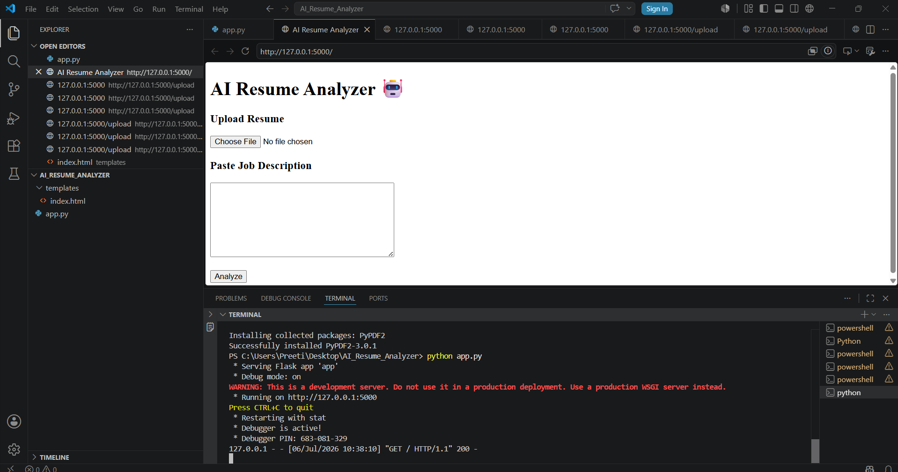

Figure 2: Resume Upload Page

This page allows users to successfully upload their resume file before starting the analysis process.

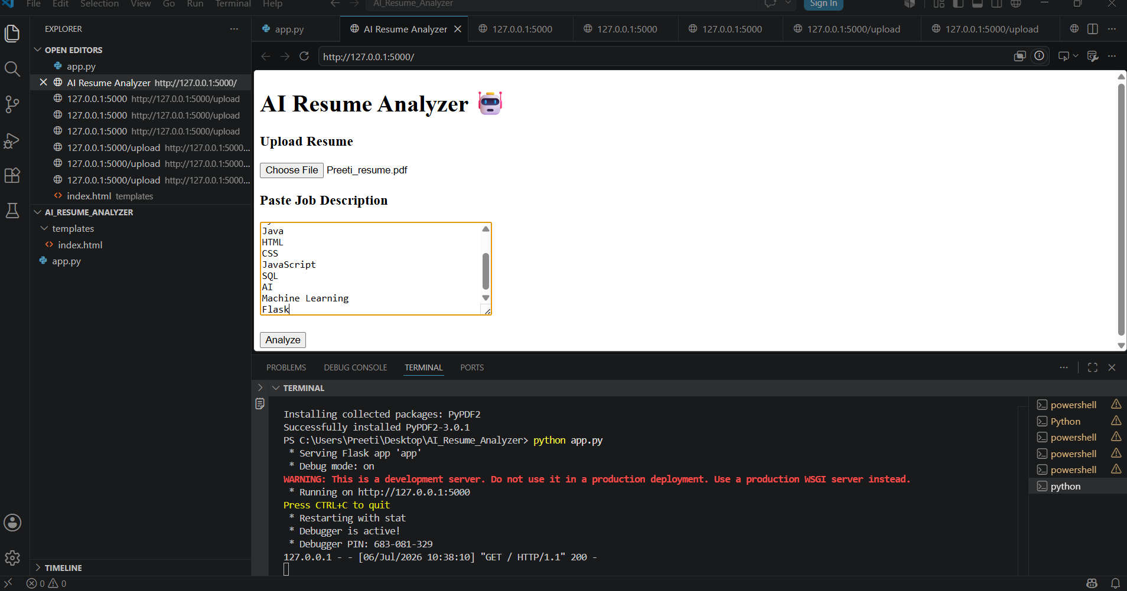
-9-
Figure 3: Result Page

After processing the resume, the application displays the Match Score, Matched Skills, and Missing Skills. This helps users understand how well their resume satisfies the job requirements.

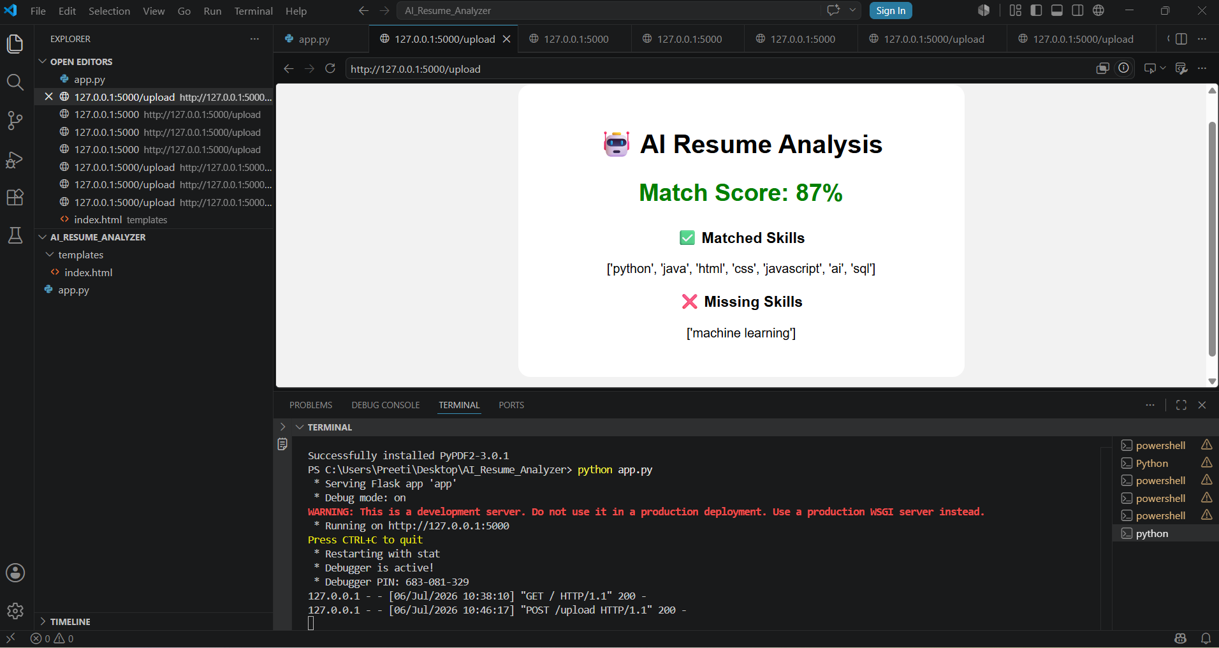

ADVANTAGES

The AI Resume Analyzer provides several benefits over the traditional manual resume screening process.

- Reduces manual effort in recruitment.
- Saves time during resume screening.
- Generates resume match scores automatically.
- Identifies important technical skills.
- Displays missing skills to candidates.
- Improves recruitment efficiency.
- Provides quick and accurate analysis.
- Easy to use and understand.
- User-friendly interface.
- Supports PDF resume analysis.

LIMITATIONS

Although the AI Resume Analyzer performs efficiently, some limitations still exist.

- The application currently supports only PDF resumes.
- Keyword-based skill detection may miss alternative skill names.
- Resume formatting can affect text extraction.
- Images inside resumes are not analysed.
- Scanned PDF files may not extract text correctly.
- The application does not evaluate experience or projects in depth.
- Semantic understanding is limited.

These limitations can be addressed in future versions of the project.
-10-

APPLICATIONS

The AI Resume Analyzer can be used in many real-world situations.

- HR Recruitment Process
- IT Companies
- Placement Cells
- Campus Recruitment
- Online Job Portals
- Resume Evaluation Platforms
- Career Guidance Systems
- Educational Institutions
- Recruitment Agencies
- Freelancing Platforms

FUTURE SCOPE

The current project can be further enhanced using advanced Artificial Intelligence and Machine Learning techniques.

Future improvements include

- Integration of Natural Language Processing (NLP).
- Machine Learning based Resume Ranking.
- ATS (Applicant Tracking System) Score Prediction.
- Candidate Recommendation System.
- Resume Improvement Suggestions.
- Experience Analysis.
- Education Qualification Analysis.
- Cloud Deployment.
- Database Integration.
- Multiple Resume Comparison.
- Email Notification System.
- Recruiter Dashboard.
- Mobile Application Development.

These improvements will make the application more intelligent and suitable for real-world recruitment.

CONCLUSION

The AI Resume Analyzer successfully automates the resume screening process by extracting text, identifying technical skills, and comparing them with job descriptions. The system generates an overall Match Score and displays matched as well as missing skills, making it useful for both recruiters and job seekers.

The project demonstrates how Artificial Intelligence concepts can simplify recruitment and improve efficiency. It reduces manual work, speeds up candidate evaluation, and provides meaningful insights into resume quality.

The application achieved its objectives successfully and can be further enhanced using Machine Learning and Natural Language Processing techniques for even more accurate analysis.
-11-
REFERENCES

- Python Official Documentation – https://docs.python.org⁠�
- Flask Official Documentation – https://flask.palletsprojects.com⁠�
- PyPDF2 Documentation – https://pypdf2.readthedocs.io⁠�
- Scikit-learn Documentation – https://scikit-learn.org⁠�
- HTML5 Documentation – https://developer.mozilla.org⁠�
- CSS Documentation – https://developer.mozilla.org⁠�
- GitHub Documentation – https://docs.github.com⁠�
- Visual Studio Code Documentation – https://code.visualstudio.com/docs⁠�

APPENDIX

Project Folder Structure

AI_Resume_Analyzer/

app.py
templates/
index.html
requirements.txt
README.md

Software Used

- Python 3.10
- Flask
- Visual Studio Code
- GitHub
- HTML
- CSS
- PyPDF2

